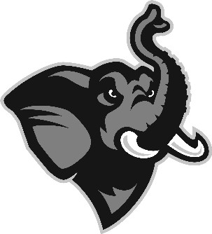

May, 2018

Dear Friends of Tufts Baseball:
I truly hope this letter finds you healthy and happy. Another season has come and gone (37 as a coach for me!) and here is my attempt to give you a quick overview. We competed well and started out a little inconsistent at the plate eventually settling on a lineup during a tough southern trip with a 5-4 record. I want to emphasize how genuinely proud I am of the way these young men conduct themselves on and off the field. The way all involved with Tufts Baseball have continued to show concern and support others continues to inspire me every day of my life. The guys were a great support system to our junior catcher Harrison Frickman and his family as his Dad battled pancreatic cancer and the team also continued to embrace our Team Impact teammate, Cooper Martin. Cooper is 7 years old and he and his sister Gracie have spent several games in the dugout. He’s a great guy full of life battling a brain tumor but has recently ended his chemotherapy so hopefully he will feel energized this summer. Our guys continue to be involved in the community as well and have stayed involved w/ with the Big Brothers of Mass Bay as well as raise funds for Homes for Our Troops.
The 2018 campaign was a successful one as we returned to the postseason and battled to reach the championship game of the 2018 NESCAC playoffs. I’m proud to announce to you that the players worked and competed hard each and every day ending the season with 20 wins. A special tip of the cap goes to our seniors who won a remarkable 111 games in their 4 years as Jumbos. We were a solid team in 2018 with multiple guys contributing to the lineup. Several young pitchers stepped up to solidify our rotation in sophomores Brent Greeley and Spencer Langdon and junior RJ Hall emerged as a force all year as our #1 starter. This team was ably led by senior captains Tom O’Hara and Nick Falkson with fellow seniors Kevin Galasso, Mike McLaughlin, Malcolm Nachmanoff (NESCAC Player of the Year), Sid Warrenbrand, Ian Kinney, Boomer Saraga, Stephan White and Christian Zazzali. They did a great job and performed admirably all year long. Tom O’Hara repeated as 1st team All NESCAC for the 4th consecutive season and broke 3 Tufts All Time Records (walks, RBIs and runs scored); he was also named 1st team All New England and got a hit in the annual College All Star game. Tom will go down as one of the best players to ever wear a Tufts uniform!! Nick Falkson was named to the 2nd team All NESCAC and as mentioned earlier Malcolm Nachmanoff was named 1st team All NESCAC and NESCAC Player of the Year as well as 1st team All New England. Finally 1st team All NESCAC honors went to pitcher RJ Hall as well.
We began our season with a challenging spring trip that consisted of 9 games in 10 days. We played some excellent teams and had a record of 5-4; highlighted by wins over ODAC playoff team Lynchburg College and NCAA qualifier Castleton St. The kids were outstanding on the trip -- first-class in every way. Never once did they make an excuse, they kept playing hard. You’d be proud of each and every one of them.
The 2018 team was led by 10 seniors and a strong junior class. Their dedication was the key to our development as a team. Also, a great deal of credit should go to my assistant coaches, Bob Kenny, Connor McDavitt, Bob Clarke and Brendan Casey. They did a great job of working with the players and keeping them focused. These coaches also put in a lot of hours helping with the golf tournament and alumni game. They serve Tufts well and deserve our appreciation.
The guys played hard all year and really matured when we returned north. Our pitching staff produced a very respectable 2.66 ERA in conference, first in NESCAC. Offensively we improved to finish the season hitting .306; leading the NESCAC. We also lead the NESCAC in home runs, RBIs and total bases. Everyone took turns coming through. Our record of 20-17 was a tribute to the kids’ ability to play hard every day. Our guys competed well and were bitterly disappointed in the NESCAC playoffs, but with a strong core of returning players in 2019, the lessons learned will serve us well.
Dave Wilbur’s Beverly HS team is having another strong season at the top of the Northeastern Conference standings!! Dave is owed special thanks for his great loyalty to the program and immeasurable help in identifying top student-athletes. Coach Kev Casey helped guide the Northeastern Huskies to their 2nd CAA Championship and a NCAA At-Large bid. Coach Jay Tower finished his 2nd season with Roger Williams Univ on top of the regular season standings a great job by Jay and his staff. Coach Paul Svagdis had another terrific season at Azusa Pacific Univ. with another 40+ win season and PacWest title; also congratulations are due to Coach Mike Daly and the Brown Lacrosse team as they competed in the Ivy League playoffs for the second straight, a lot more success is coming to Providence, RI!
We had some outstanding individual efforts this season and several of our players were awarded post-season honors:

Kevin Galasso, senior, All NESCAC Sportsmanship team
RJ Hall, junior, 1st team All NESCAC,
Nick Falkson, senior, 2nd team All NESCAC,
Tom O’Hara, senior, 1st team All NESCAC, 1st team All New England, D3.com All Region
Malcolm Nachmanoff, senior, 1st team All New England, 1st team All NESCAC, D3.com All Region, NESCAC Player of the Year
We also have 3 guys placed on the NESCAC All-Academic team for the Spring Season!!!
Justin Mills, Will Shackelford and Christian Zazzali

2019 Tufts Baseball Captains:
Harrison Frickman, Will Shackelford, RJ Hall

I’m extremely proud of these young men and the honors they have brought to the University. We are committed to work even harder to win the league crown in ‘19. On behalf of the players and my staff, I extend particular appreciation to all those who responded to our requests for help for our 2018 Spring Trip and especially those who became Diamond Club members. In a remarkable display of loyalty we have 78 and counting Diamond Club members in 2018. That is our largest number ever so if you are so inclined please feel free to become a Diamond Club member. We play one of the toughest schedules in New England and feel proud to carry on that tradition. We are scheduling 2019 contests now against such opponents as Methodist, Lynchburg College, Guilford College, Christopher Newport, Virginia Wesleyan and Roanoke. We look forward to your support in ‘19.

In closing, thanks for your support and enthusiasm; we are constantly working to improve our program and facilities. It has long been a goal for our players to leave the program better than when they came in. We’ve come a long way and are working hard to finish things off. I would like to again publicly thank all those alumni whose generosity made this work possible. Your efforts have made our indoor and outdoor facilities among the best in New England. Our field is a great source of pride for the program and we take a back seat to no one in having the top facilities in New England- with your support we will continue to get it done.
As you are hopefully aware we have kicked off our campaign to build a new field. It will take a great response from alums and friends of the program but we believe that this project will become a reality. The plans call for a lighted turf field with seating for 600 or so. I truly believe the future success of Tufts baseball is directly tied into the success of this project. There are already 3 turf fields in other NESCAC programs with more on the way. This field will not only allow us to continue to attract the best student athletes to Tufts but also reduce a lot of stress for our current players as we will be able to practice later (avoiding any class conflicts) and get on the field earlier in the year (better prep) as well as avoid more postponements and rescheduling (no more 12 games in 10 days down the stretch). I am happy to come meet with you or speak with you anytime, if you are interested in lending some support to the project. john.casey@tufts.edu 617-627-5218 office, 508-733-0521 cell.

I have enclosed an additional form to help in identifying student-athletes (your help is greatly appreciated here
Special thanks to those alumni who referred prospective student-athletes. Your referral network for players is a huge boon to our recruiting efforts.

Have a Great Summer!
Yours in Baseball,
Coach Case
John W. Casey, A’80, G’83
Head Baseball Coach
2018 Tufts Baseball-Final record 20-17
2018 NESCAC Eastern Division Champions
P.S. Our kids take great pride in wearing the Tufts uniform and in living up to the great tradition
of Tufts baseball that’s been left to them by all of you. THANK YOU!!
Let’s make this a reality
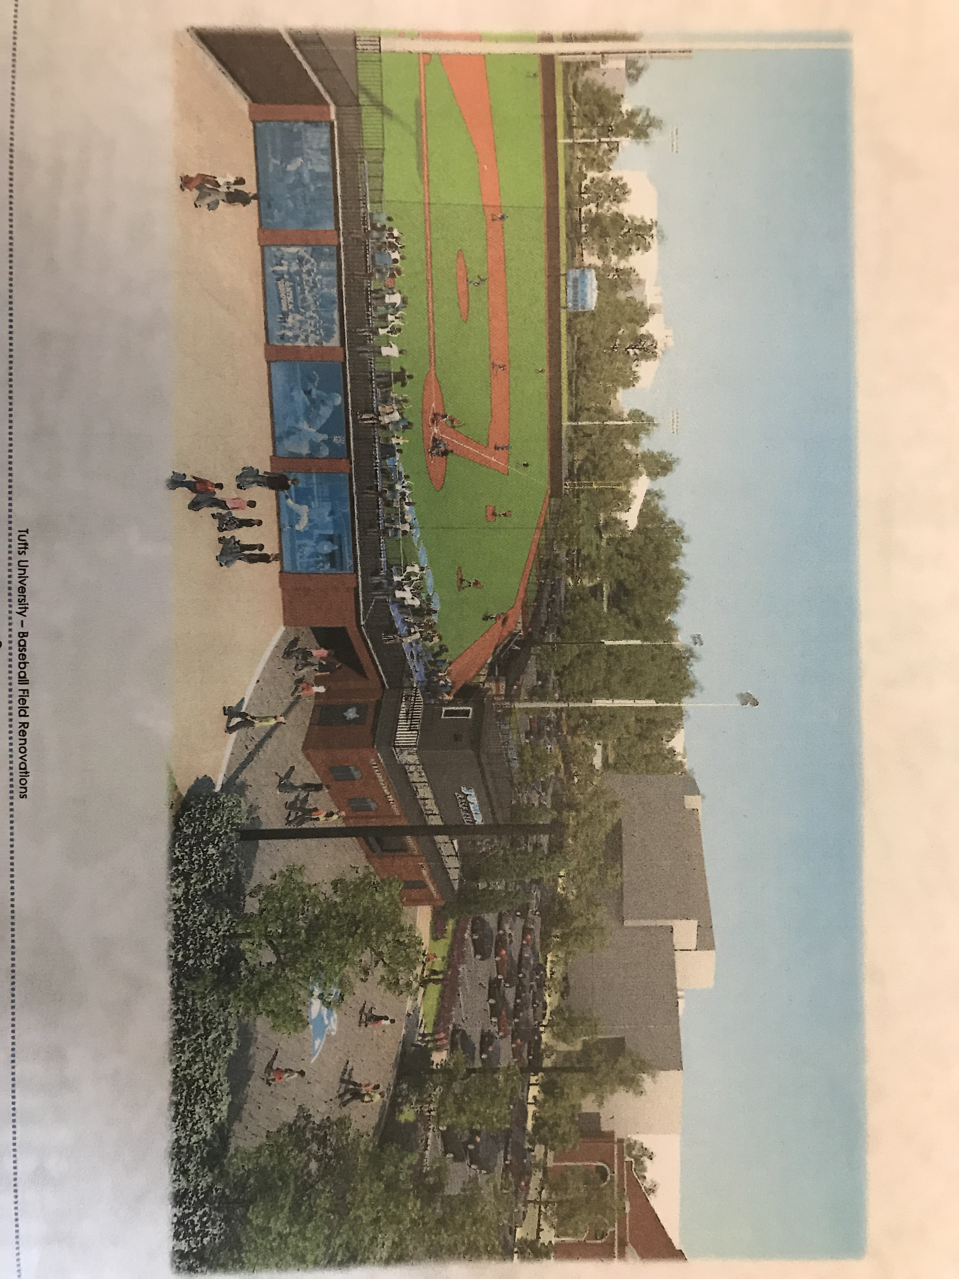

NOTICE

Alumni Pictures and video of swings off the 1st tee now available

Please check the Tufts Baseball Alumni website for a recap of our alumni weekend as well as pictures and videos from Alumni weekend. Pictures from all foursomes as well as other shots from both the golf tournament and the alumni game will be posted. Enjoy!!

BE SURE TO DOWNLOAD YOUR PICTURE OFF THE SITE
Go to the galleries tab and hit golf tournament the pix will be there
The website address is:

www.jumbobaseball.com

Identifying student-athletes is crucial to our success. We need you help. If you know of any good players in your area, please let us know about them. Just send along or email this form. Your help is crucial and greatly appreciated. john.casey@tufts.edu

Tufts University Baseball
Alumni-Prospect Referral

Your name:
Player’s name: Year in school: Ht: Wt:
Home Address: Bats: L / R Throws: L / R
High School: Position:

High Low
Your overall assessment of player’s ability: 1 2 3 4 5 (Please circle one)
Player’s interest in Tufts: 1 2 3 4 5 (Please circle one)
Comments:

